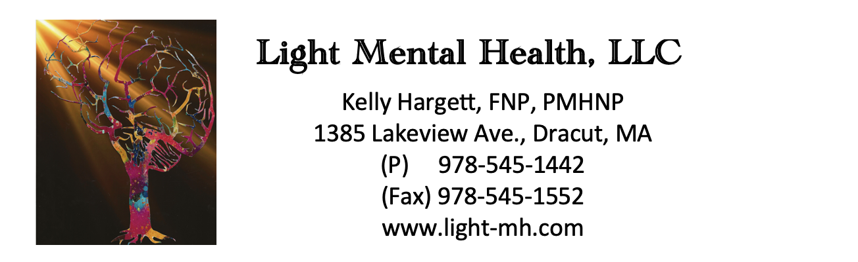

**Authorization for disclosure of protected health information (18+)**

I, (patient name) __________________________________ Date of Birth: __________________

Authorize **Light Mental Health, LLC** to disclose the following information from my protected health record to the below listed recipient (s):

__ I authorize the release of my entire health record (excluding ALL sensitive health information)

I authorization the release of the following records (Check all that apply):

__ Mental Health Records

__ Drug and Alcohol Abuse Treatment Records

X

__ Other (please specify): _________________________________________________________

I authorize **Light Mental Health, LLC** to provide the above information to:

Communicate regarding mental health treatment plan

Name of person/facility: __________________________________________________________

Relationship: ________________________ For the purpose of: __________________________

12/2026

This authorization is valid from the date of signature until EXPIRATION DATE______________

*This authorization to release information will expire two (2) years following the signature date or on the expiration date noted, whichever comes first.*

____________________________________ _______________________

Signature of patient Date

___________________________________ _______________________

Signature of Personal Representative Date